Creating Branches in GIT:

Branch in Git is a pointer to some commit.

By default Git was pointing to the default branch called “master”. Suppose on your project if you have multiple team working on different modules and few members are from testing those developed code and if everyone committed to a same branch master, it would be a huge mess and there will a highly chance to delete or override the codes in a branch.

To overcome this problem for every module we can create a new branches and developers and testers can work on those branches. Once everything is fine and it is approved by the management we can merge all branches of code to a master branch.

By doing this way the possibility of corrupting the master branch is minimal.

Now let’s see how we can create a branch on your local repository. To create a branch in your repository, you can use the following command.

# git branch <branch name>

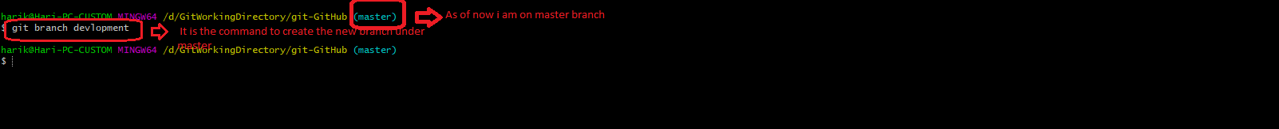

Note: creating branch will not take any extra space, it is only a pointer to commit the code.

Once you create a branch, the file that are already on the git repository are pointer to both master and development branches and if you are in master branch and creating new files are also pointing to both branches.

Now if suppose once one switch to the development branch and creating a file will only point to that development branch.

In order to switch to the newely created branch, we can use the following command.

# git checkout <branch name>



To list all the branches available on your repository and the present repository you are residing, issue the following command.

# git branch

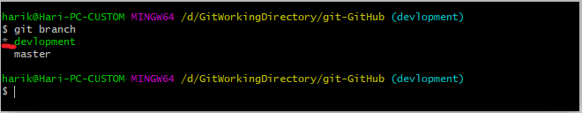

Now switch back to master and list the files it has

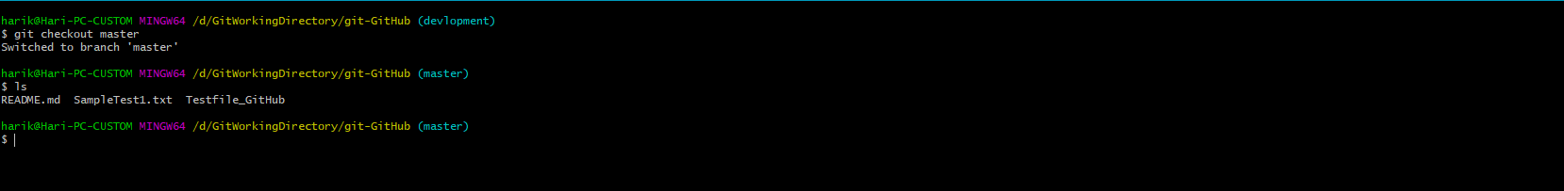

Now again switch back to development branch and list files it has

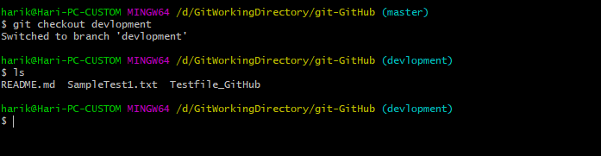

As I said you previously, those files are already create before creating branches so those are pointers and files are pointing to both branches.

Now create a new file while you are on development branch and see if it is available to master branch also.

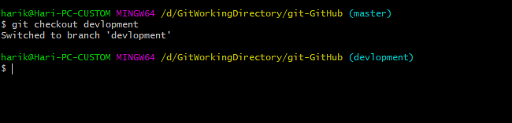

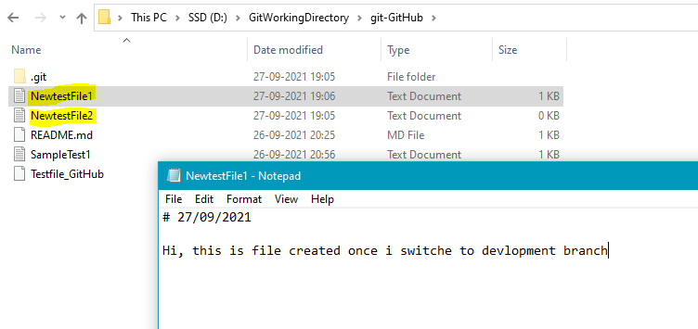

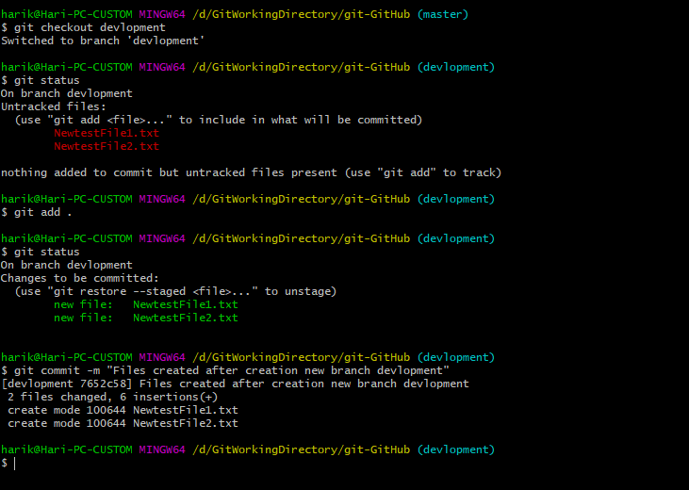

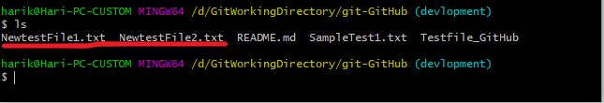

Checkout to master now and see if this file will be visible or not.

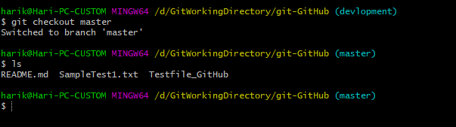

Here you can only three, the files created on development branch will only be visible once switch to development branch. It means until you merge the development branch under master those new files won’t be visible under master branch.

